Barcode ID Badge Template

To Make an ID badge, you will need the barcode information from the User and some basic identifiable information, like First Name, Last Initial or Last Name, First Name, Middle Initial for example. If it is a generic badge, then something like Student #12 would be sufficient.

Medication Cart ID:

<Identity>

Unauthorized use is prohibited.

<Barcode/QR Code>

SVSU CIS Med Cart

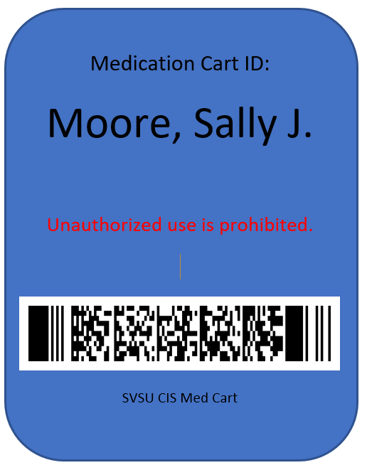Examples: 